Chapter 13, Problem 58.

Determine the average power absorbed by each resistor in the circuit of
Fig. 13.122.

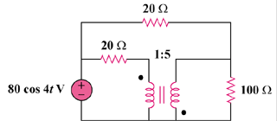

Figure 13.122
For Prob. 13.58.

